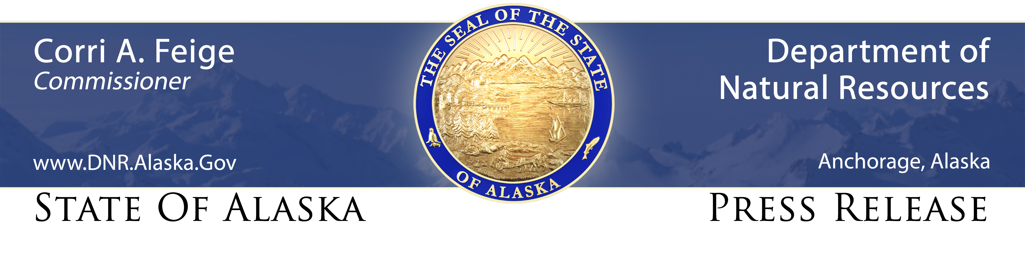
For Immediate Release: January 21, 2021

Micro-grants available to improve security of Alaska’s food supply

(Palmer, AK) – With the global COVID-19 pandemic reminding Alaskans they live at the end of a long and sometimes tenuous food supply chain, the state’s Division of Agriculture is offering micro-grants aimed at strengthening local food security.

“While Alaska enjoys the benefits of a global supply system, it is simply responsible to support home-grown systems we can rely on, just in case,” said David W. Schade, director of the division. “We are fortunate to now be able to offer micro-grants aimed at enhancing our ability to be more self-reliant when it comes to necessities like food.”

The 2018 federal Farm Bill authorized the State to issue micro-grants to support innovative ways to improve Alaska’s food security. The division has begun accepting scoping applications for three-year grants of up to $15,000 for individuals, or $30,000 for qualified organizations. The U.S. Division of Agriculture will provide $1.8 million to the division in each of the program’s first two years.

“We will prioritize funding of grants for projects that will increase local food production and storage, as well as education efforts to support these local efforts,” Schade said. Qualifying activities may include small-scale gardening, small-scale herding and livestock operations, and/or expanding access to food, safe food storage, and knowledge of food security.

Grant applicants must provide an initial scoping application to the division by Feb. 15. The division will then invite qualifying applicants to submit a full project proposal. Multiple individuals or organizations may submit joint applications for grants to support coordinated activities. The initial scoping application form and deadline information are available online at: http://dnr.alaska.gov/ag/ag_grants.htm.

All individual Alaskans and most organizations qualify to apply for these grants, and the division hopes to have a strong batch of applications in the program’s first year. The security of two years of federal funding means projects the division cannot fund in 2021 will have another chance next year, Schade said.

CONTACT: Catherine Cheadle, 907-761-3851, catherine.cheadle@alaska.gov

###

